DOI: https://doi.org/10.61225/rjrs.202X.XX

TITLE OF THE PAPER – TIMES NEW ROMAN 12 UPPERCASE BOLD, 1.5 spaced
Author 1^{a,}* , Author 2^{b}, Author 3^{c} Times New Roman 12 Bold, 1.5 spaced

ª Affiliation (include name of the university, and country) Times New Roman 12, 1.5 spaced
^{b} Affiliation (include name of the university, and country) Times New Roman 12, 1.5 spaced
^{c} Affiliation (include name of the university, and country) Times New Roman 12, 1.5 spaced
* Corresponding author:
Address:
E-mail:

Biographical Note(s)

Author 1 is …. Her (his) research interest ... Times New Roman 12, 1.5 spaced. Maximum 100 words. ORCID ID:

Author 2 is …. Her (his) research interest ... Times New Roman 12, 1.5 spaced. Maximum 100 words. ORCHID ID:

Author 3 is …. Her (his) research interest ... Times New Roman 12, 1.5 spaced. Maximum 100 words. ORCID ID:

Abstract
Times New Roman 12, single spaced
Keywords: Times New Roman 12, single spaced. Up to 7 keywords
JEL Classification: Times New Roman 12, single spaced. Available at http://www.aeaweb.org/jel/jel_class_system.php

1. Introduction
First paragraph - Times New Roman 12, 1.5 spaced.
Second and following paragraphs - Times New Roman 12, 1.5 spaced.

2. Literature review
First paragraph - Times New Roman 12, 1.5 spaced.
Second and following paragraphs - Times New Roman 12, 1.5 spaced.

3. Method
First paragraph - Times New Roman 12, 1.5 spaced.
Second and following paragraphs - Times New Roman 12, 1.5 spaced.

4. Results and Discussion
First paragraph - Times New Roman 12, 1.5 spaced.
Second and following paragraphs - Times New Roman 12, 1.5 spaced.

Table 1. Title. Times New Roman 12, 1.5 spaced, align left
The table content should be written with Times New Roman 12, single spaced and the alignment should be centred.
Example:
Table 1. The variables of the model
Variable name | Description | Data source
EXP_rate | Annual average growth rate of export per capita over the period of interest. | National Institute of Statistics and own computations
EXP/cap_initial | Export per capita (euro) at the beginning of the period of interest. | National Institute of Statistics and own computations
IMP/cap | Import per capita (euro). | National Institute of Statistics and own computations
Source: Own representation. Times New Roman 10, 1.5 spaced, align left

Figure 1. Title Times New Roman 12, 1.5 spaced, align left
The figure should be centred.

Example:
Figure 1. Spatial distribution of the average annual growth of counties’ exports during 2001-2014
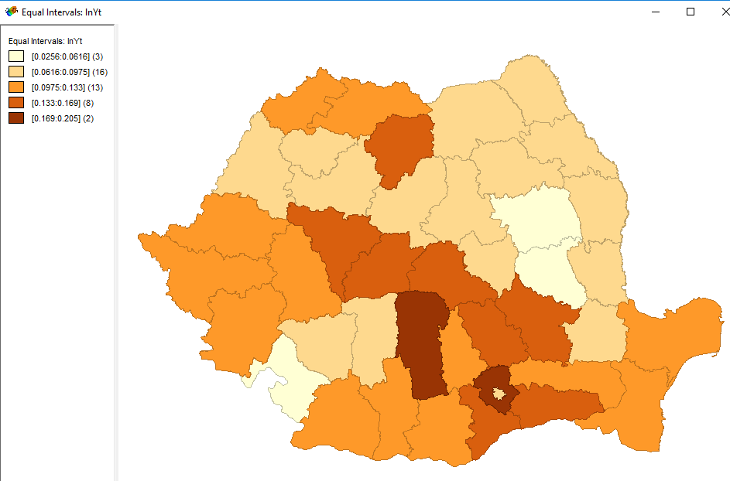
Source: own processing in Geoda 1.7. Times New Roman 10, 1.5 spaced, align left

Formulas should be centered and numbered.

Tables, figures, and formulas should be numbered consecutively with Arabic numbers. Authors are kindly asked to insert the tables and figures as close as possible to the first reference to them in the paper.

5. Conclusion
First paragraph - Times New Roman 12, 1.5 spaced.
Second and following paragraphs - Times New Roman 12, 1.5 spaced.

References
Both in text citations and the references list should be written in accordance with the Harvard style. A very comprehensive Guide to the Harvard System of Referencing is available at http://libweb.anglia.ac.uk/referencing/harvard.htm
We kindly ask all authors to follow the instructions specified in the guide.
Some of the most common examples can be found below:

For in text reference:
One author: - direct citation: Lundgren (2017) approaches various aspects on openness and transparency in political decision making.
- indirect citation: "Studies of openness and transparency in a regional political decision making context, across geographies, organizations and time are certainly interesting lanes to further explore." (Lundgren, 2017, pp.117-118).
Two authors: Zaman and Goschin (2017) present ....
Three authors: Behboudi, Razi and Rezaei (2017) outline .....
More than three authors: Zambon et al. (2017) highlight ....

For the Reference list
Books:
Author, Initials., Year. Title of book. Edition. (only include this if not the first edition) Place of publication (this must be a town or city, not a country): Publisher.

Altman, I. and Low, S.M., 1992. Place Attachment. New York: Plenum Press.
Bell, P.A., Green, T.C., Fisher, J.D. and Baum A., 2001. Environmental Psychology. 5th ed. New York: Psychology Press, Taylor and Francis Group.

Chapter in edited books:
Chapter author(s) surname(s) and initials., Year of chapter. Title of chapter followed by In: Book editor(s) initials first followed by surnames with ed. or eds. after the last name. Year of book. Title of book. Place of publication: Publisher. Chapter number or first and last page numbers followed by full-stop.

Constantin, D.L., Grosu, R.M., Herteliu, C. and Dardala, A., 2015. Regional disparities and equal access to healthcare: A case study of Romania. In: H. Fassmann, D. Rauhut, E. Marques da Costa and A. Humer, eds. 2015. Services of General Interest and Territorial Cohesion. European Perspectives and National Insights. Vienna: V & R unipress, Vienna University Press. pp.209-220

Articles in scientific journals:
Author, Initials., Year. Title of article. Full Title of Journal, Volume number (Issue/Part number), Page number(s).

Bonaiuto, M., Fornara, F. and Bonnes, M., 2003. Indexes of perceived residential environment quality and neighbourhood attachment in urban environments: a confirmation study on the city of Rome. Landscape and Urban Planning, 65(1-2), pp. 41-52.

Articles in scientific journals with DOIs:
Author, Initials., Year. Title of article. Full Title of Journal,[e-journal] Volume number (Issue/Part number), Page numbers if available. DOI inserted as link. To search for the DOI, please visit: http://www.crossref.org/guestquery/ . To create a link, select the DOI web address, then right click, select Link.

Brown, G. and Raymond, C., 2007. The relationship between place attachment and landscape values: Toward mapping place attachment. Applied Geography, [e-journal] 27(2), pp. 89–111. https://doi.org/10.1016/j.apgeog.2006.11.002

Online articles:
Author or corporate author, Year. Title of document or page. Name of newspaper, [type of medium] additional date information. Available at: <url> [Accessed date].

Florida, R., 2009. The soul of the city. The Atlantic, [online] 1 October. Available at: <http://www.theatlantic.com/national/archive/2009/10/soul-of-the-city/27526/> [Accessed 29 September 2017].

Conference papers:
Author, Initials., Year. Full title of conference paper. In: followed by editor or name of organisation, Full title of conference. Location, Date. Place of publication: Publisher.

Constantin, D.L., Mitruţ, C., Goschin, Z., Grosu, R. and Iosif, A., 2013. The Employment of Multi-Criteria Analysis for municipal property management: Some Theoretical Considerations. In: RRSA and Danubius University of Galati, 9th International Conference of the Romanian Regional Science Association - "Regional Development Between Recent Experiences and Future Challenges". Galati, Romania, 26-27 April 2013. Galati: Danubius University Press.

Appendix

Table A1. Times New Roman 19, 1.5 spaced

We kindly ask all authors to follow the template recommendations. Compliance with the template is mandatory for publishing the articles.

